Week 5 Report

Progress this week
- Reviewed Ihor's coded-marker scale implementation and PR 19 against the colour-calibration branch. The scale protocol is complementary to PR 18 and has no direct file conflict.
- Audited every locally available PLY and documented a dense-geometry validation protocol. The named VGGT/COLMAP files are sparse and the historical meshes are unlabeled, so none can support a defensible anatomical comparison
- Recovered real chart references for UF_Herp_3998 and UF_birds_ivory2 and compared the current linear 3 by 3 correction with a degree-2 root-polynomial model using leave-one-patch-out evaluation.
- Stress-tested the complete directory-calibration pipeline on eight real multicolour fish texture maps under two controlled camera responses. All 16 outputs completed with no skips or clipping increase.

Key results
Metric | Result | Interpretation
Held-out chart predictions | 96 | 2 specimens × 4 camera cases
Linear mean held-out ΔE76 | 2.573 | Current PR 18 method
Root-polynomial mean ΔE76 | 2.791 | +8.4% worse
Fish textures / calibrated outputs | 8 / 16 | Two camera responses
Fish mean foreground ΔE76 | 3.136 → 0.158 | 95.7% reduction
Worst fish-case improvement | 89.2% | All cases improved
Clipping increase | 0.000 pp | Both camera responses

Blockers and limits
- Absolute calibration is still waiting on the physical ColorChecker manufacturer, model, and patch-value edition.
- Dense geometry validation still needs a labeled, densely tessellated structured-light or CT reference paired with the same specimen's photographs. The current sparse-Delaunay result is only a coarse reconstruction check.
- The fish archive contains finished OBJ/texture assets, not raw camera photographs or chart frames

2. Literature review

Root-polynomial colour correction
Finlayson et al. explain that ordinary polynomial colour correction can reduce fitted error but loses the exposure-scaling property of a linear 3 by 3 transform. Their root-polynomial terms retain exposure homogeneity while adding nonlinear capacity. This directly motivated the degree-2 model evaluated this week
Citation: Finlayson, G. D., Mackiewicz, M., & Hurlbert, A. (2015). Colour correction using root-polynomial regression. IEEE Transactions on Image Processing, 24(5), 1460–1470. https://doi.org/10.1109/TIP.2015.2405336

Polynomial camera characterization and sample support
Hong et al. study digital-camera characterization with polynomial models and examine how polynomial degree and the number of colour samples affect accuracy. The paper reinforces that additional terms must be supported by enough independent calibration data. With only one 24-patch chart per camera, this supported our decision to use held-out patches and a predeclared adoption gate instead of selecting the model with the lowest fitted error.
Citation: Hong, G., Luo, M. R., & Rhodes, P. A. (2001). A study of digital camera colorimetric characterization based on polynomial modeling. Color Research & Application, 26(1), 76–84. https://doi.org/10.1002/1520-6378(200102)26:1%3C76::AID-COL8%3E3.0.CO;2-3

Interpreting perceptual colour differences
Sharma et al. document the CIEDE2000 formula, implementation edge cases, and reference test data, showing why colour-difference results depend on the chosen metric and a verified implementation. We retained ΔE76 in this week’s experiment for continuity with the existing PR evidence, but reported the formula explicitly and treated the values as comparative errors rather than universal perceptual thresholds.
Citation: Sharma, G., Wu, W., & Dalal, E. N. (2005). The CIEDE2000 color-difference formula: Implementation notes, supplementary test data, and mathematical observations. Color Research & Application, 30(1), 21–30. https://doi.org/10.1002/col.20070

3. What I did and how I verified it

Coded-marker integration review
Ran the focused scale and mesh suites: 26 tests passed, 6 were skipped, and 3 unrelated failures came from macOS lacking os.sched_getaffinity. Flagged repeated short rings and one-ring captures as protocol edge cases.

Geometry-readiness audit
Classified six historical dense-looking meshes as unlabeled and the named VGGT/COLMAP outputs as sparse. Preserved the earlier 33/36 registration comparison as coarse evidence only and wrote the exact future reference-mesh protocol.

Held-out colour-model comparison
Used leave-one-patch-out predictions across two specimens and four non-reference camera cases. Root polynomial worsened mean ΔE76 by 0.217; the paired bootstrap 95% interval was −0.017 to +0.454, and three of four camera cases worsened.

Multicolour pipeline stress test
Downsampled eight real 8192×8192 RGBA fish textures to 1024 pixels, retained alpha masks, synthesized two camera responses from real fitted matrices, and invoked the full production calibrate_directory path.

4. Results visualization
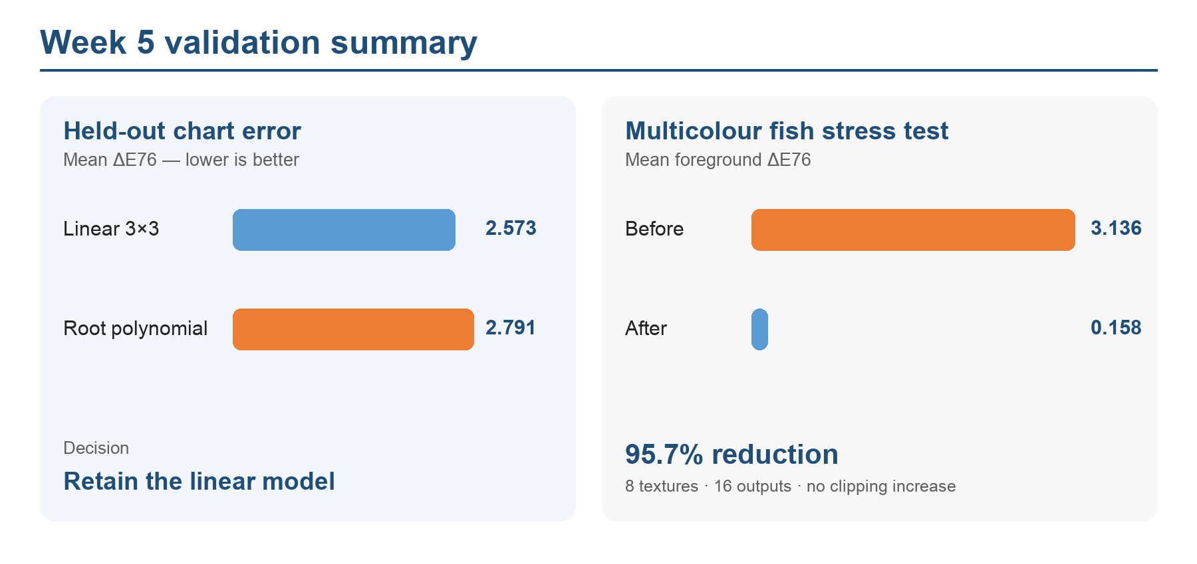
Figure 1. The more complex root-polynomial model was worse on held-out chart patches, while the production pipeline sharply reduced controlled colour error across eight multicolour fish textures.
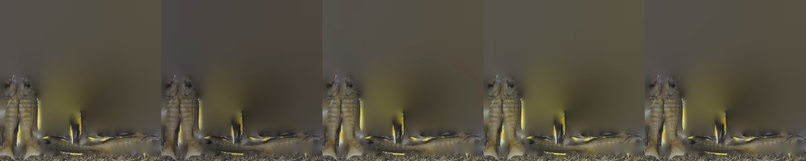
Figure 2. Representative preview strip: target texture followed by camera-2 before/after and camera-3 before/after. This is a controlled stress test using real texture content, not an independent field capture.

5. Conclusions and decisions
- Retain the linear 3 by 3 model in PR 18. The higher-order model did not show a reliable held-out gain and was worse on average.
- Use the fish result as evidence that the implementation handles high-resolution, multicolour RGBA assets and masks; do not present it as independent biological colour validation.
- Keep colour calibration, metric scale, and geometry validation as separate provenance-controlled stages, then test their interaction after each stage is individually accepted.
- Waiting on a paired structured-light/CT reference to become available before making dense or anatomical geometry claims

Evidence and artifacts
Artifact | Location
Higher-order model report | documentation/root-polynomial-held-out-comparison-2026-10-02.md
Model comparison data | outputs/color-model-held-out-comparison-2026-10-02.json
Fish stress-test report | documentation/multicolor-fish-pipeline-stress-test-2026-10-02.md
Fish stress-test data | outputs/multicolor-fish-pipeline-stress-test-2026-10-02.json
Scale integration review | documentation/coded-marker-scale-integration-review-2026-10-02.md
Geometry readiness | documentation/color-calibration-dense-geometry-readiness-2026-10-02.md
Meeting and Slack record | documentation/meeting4-transcript.md; documentation/slack/raw/refresh-2026-10-02.md

Next week
- Complete the reviewer/Slack handoff for PR 18
- Review Neuralangelo, NeuS2, NeuS, and newer candidates, then select one reproducible masked baseline.
- Review the recent dataset/benchmark papers Syed shortlisted and extract concrete failure-analysis, ablation, and qualitative-comparison requirements for our publication.
- Compare MorphoSource and Hugging Face for public release: supported formats, 3D preview, metadata, versioning, licenses, citations, and download ergonomics.
- Rerun absolute colour calibration when the chart edition is confirmed, and run dense reference-mesh validation when a matched specimen becomes available.

